|  |  |
| --- | --- |
|  | **FPT ACADEMY INTERNATIONAL**  **FPT – APTECH COMPUTER EDUCATION** |

**Java Florist**

Installation Guide

|  |  |  |
| --- | --- | --- |
| **Advisor:** | MR. HOANG DUC QUANG | |
| **Semester:** | 3 | |
| **Batch No:** | T1.2203.E1 | |
| **Group No:** | 2 | |
| **Order:** | **Full name** | **Roll No.** |
| 1. | Bui Minh Tin | Student1370240 |
| 2. | Nguyen Ngoc Minh | Student1370242 |
| 3. | Le Hoang Thanh Phat | Student1372897 |

August 2023

1. **Software and Hardware Requirement**
2. **Hardware requirement**

|  |  |
| --- | --- |
| **Component** | **Requirement** |
| **Server** | **Processor type:**  **Pentium III-compatible processor or faster**  **Processor speed:**  **Recommended: 2.0 GHz or faster** |
| **OS** | **Microsoft Windows 2008 or higher** |
| **Memory (RAM)** | **RAM:**  **Minimum: 512 MB**  **Recommended: 2.048 GB or more**  **Maximum: Operating system maximum** |
| **Hard Drive** | **Free space:**  **Minimum: 50 MB**  **Recommended: 50 GB or more**  **Maximum: Operating system maximum** |

1. **Software requirement**

|  |  |
| --- | --- |
| **Component** | **Requirement** |
| **Microsoft .NET Framework** | **Version 4.6** |
| **Microsoft Visual Studio** | **Microsoft Visual Studio 2022** |
| **RDBMS** | **Microsoft SQL Server Management Studio 18** |

1. **Configuration**
2. **Database configuration**

Open SQL Server Management Studio and connect to SQL SERVER

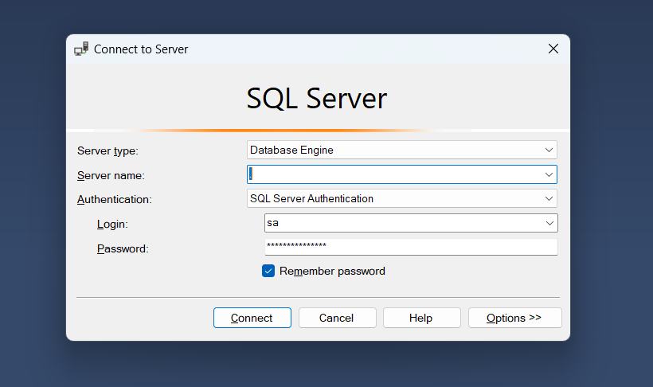

And then File => Open => File

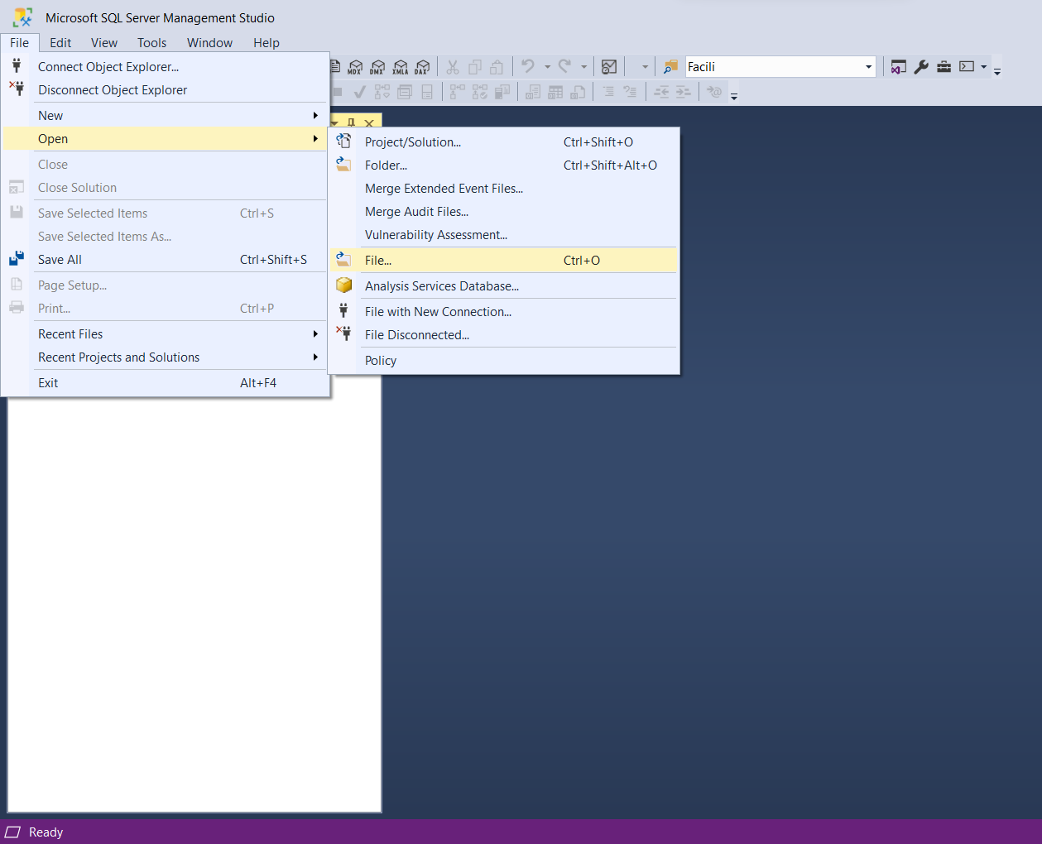

Choose file ITMCollegeDb.sql in db folder to Open

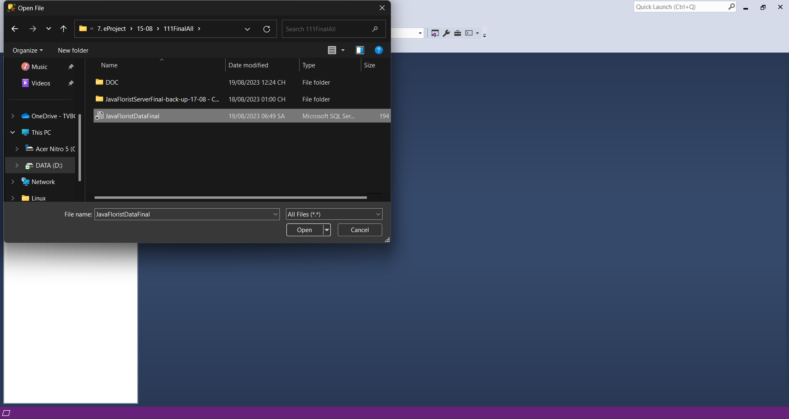

Database will generated when you click => Execute

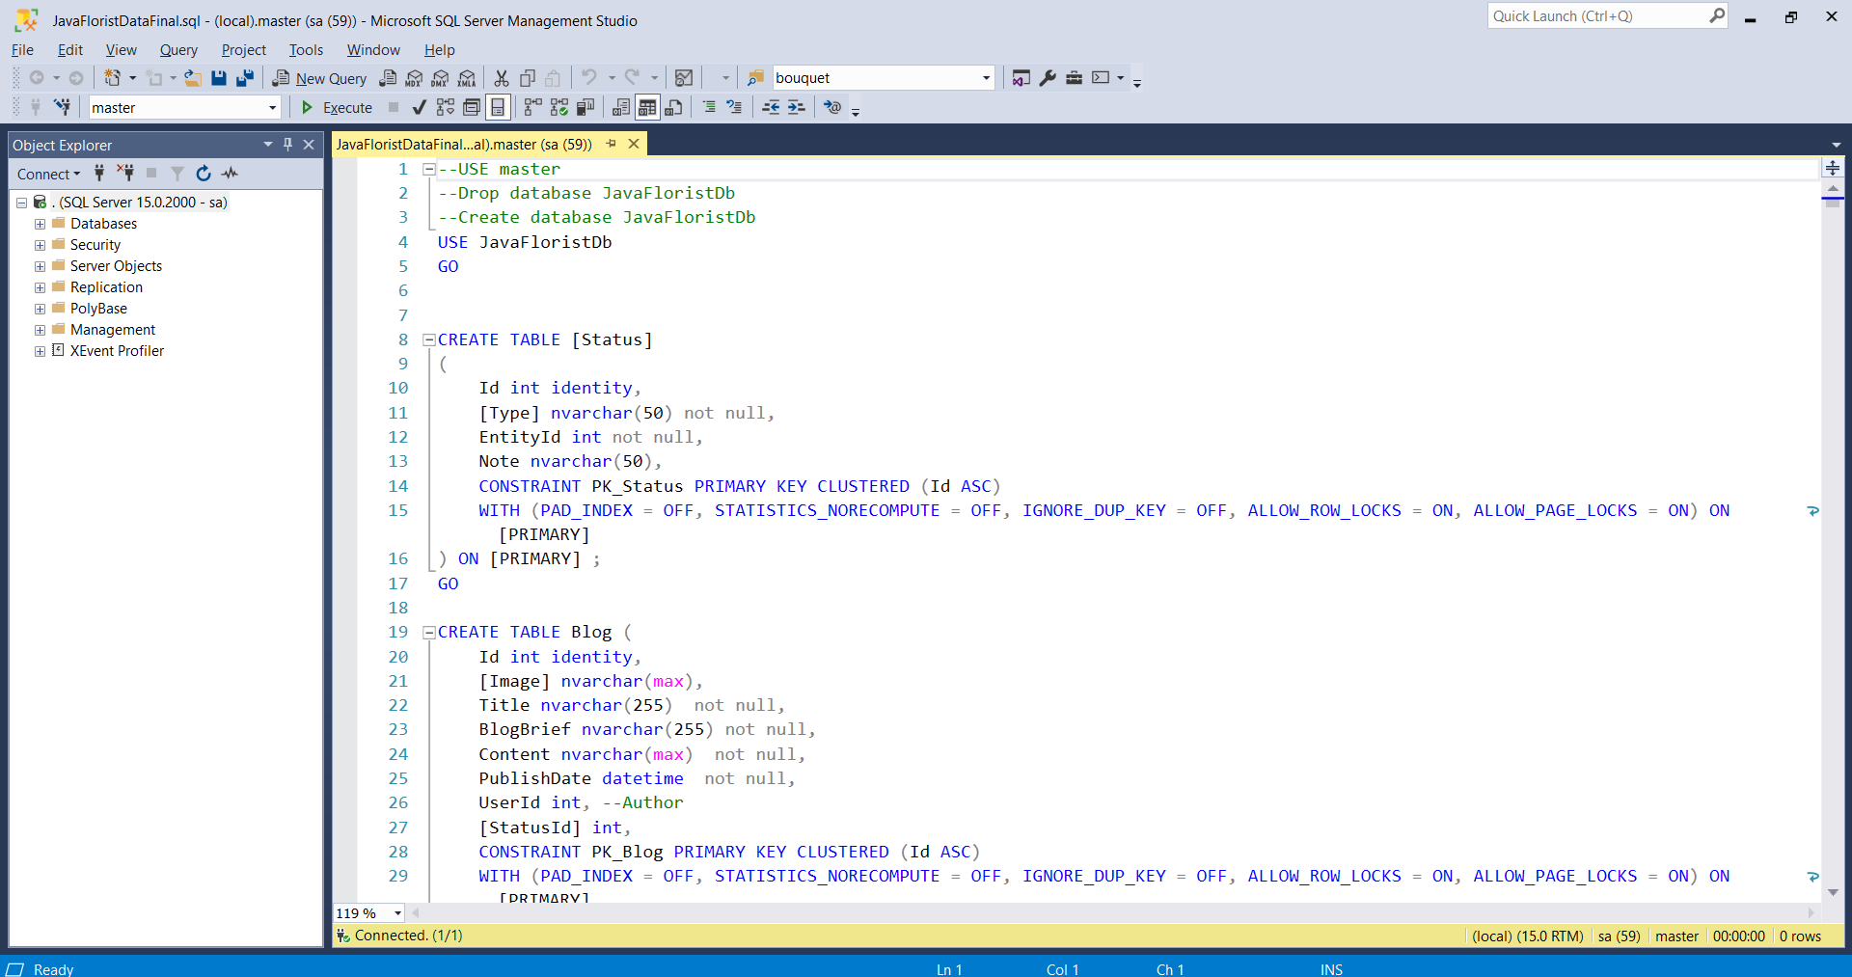

1. **Open Project**

Open Visual Studio, click File => Open => Project/Solution…

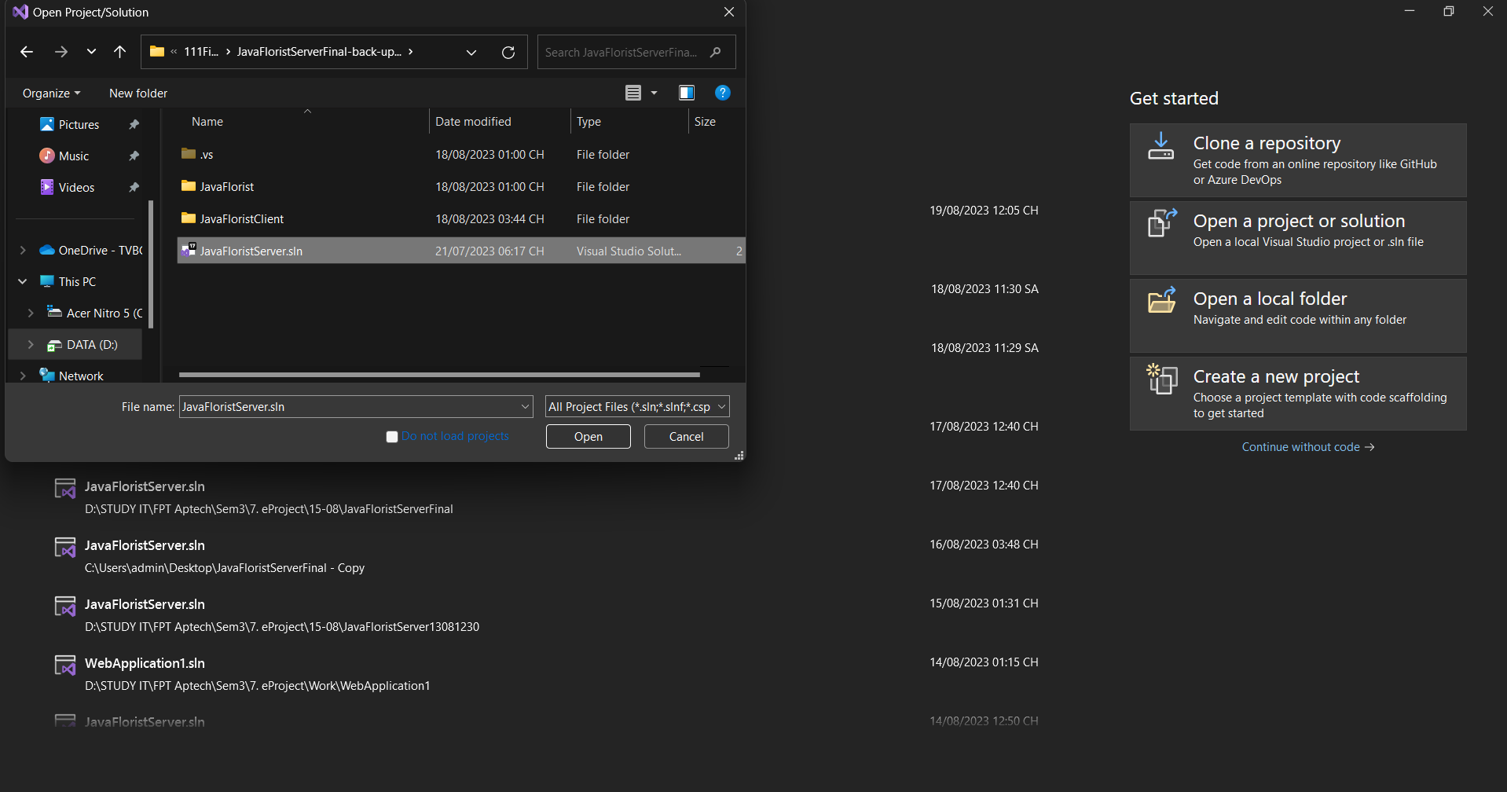

Click JavaFloristServer.sln to run project

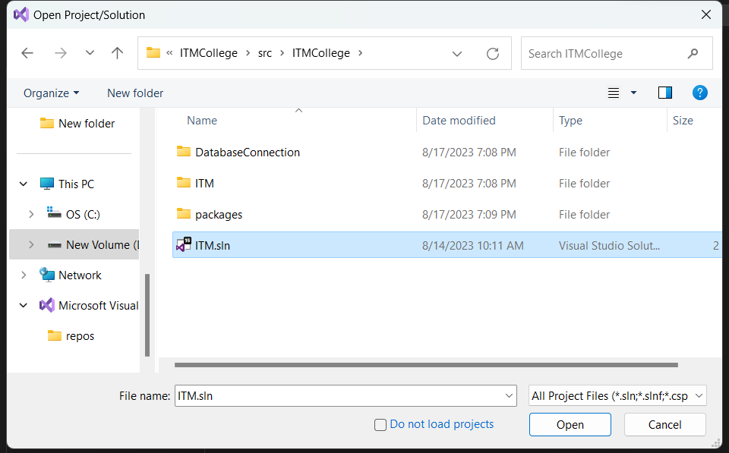

After you run the project, click on Web.config to edit the Connection String

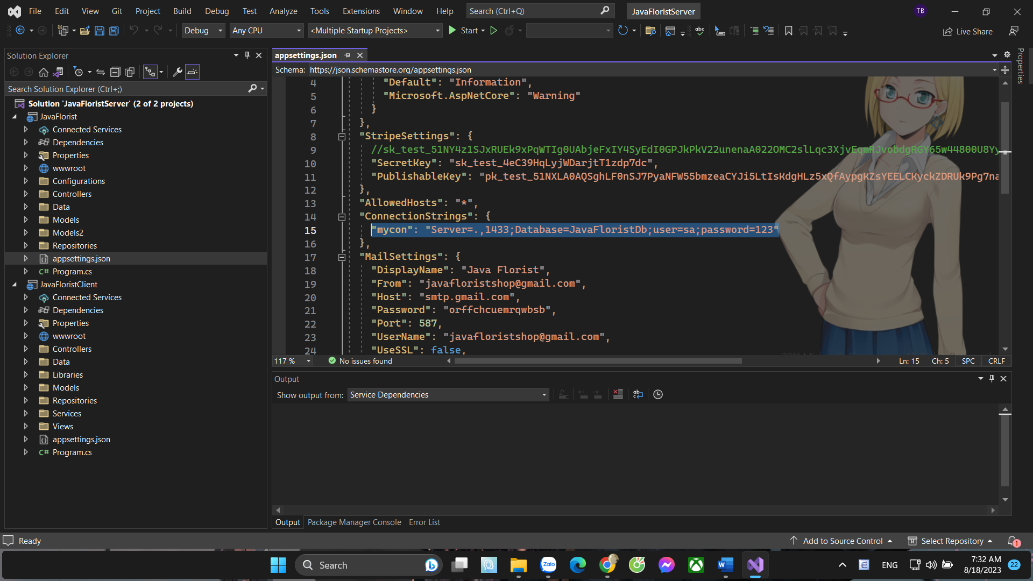

Edit <connectionString>

* Data Source: SQL Server name (Example: localhost)

If login by SQL Server Authentication

* User ID: Username to log on SQL Server
* Password: Password to log on SQL Server

After you edit the connectionString, click Build on menu bar and choose Build Solution

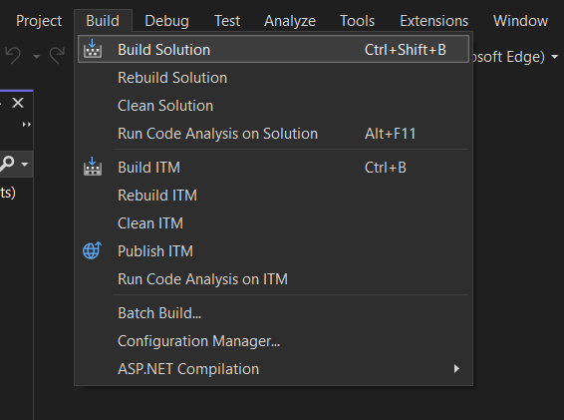

1. **Publish Website**

**Publish website from Microsoft Visual Studio**

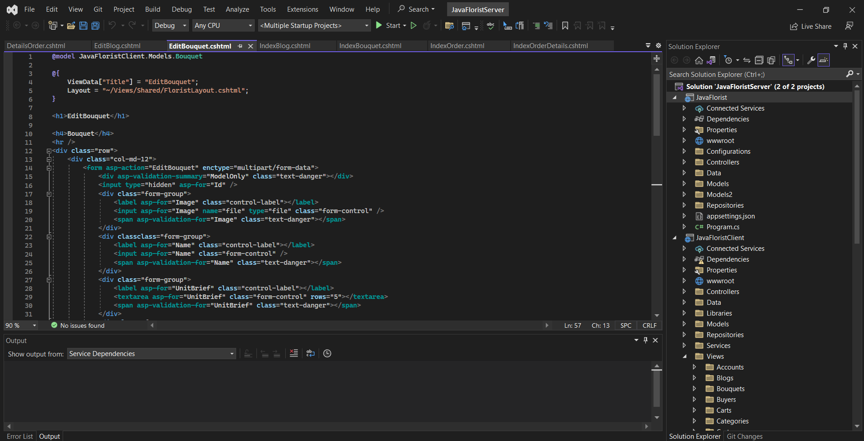

The website now loading in web-Browser



